Ramp-Trim Captura to Context

  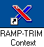

TRIM Context Check List 1
TRIM Context Registration: Editing, Revising 2
TRIM Context Double Clicking 3
Context Sensitive Right Mouse Click 3
TRIM Context Searching 4
TRIM Context User-Friendly Enhancements:
Sorting, Formatting, Printing and Help 5
Modify Commands and Functions in Context 5

TRIM Context Check List
□Registration
□Double-clicking
□Right-clicking
□Searching
□Sorting
□Formatting columns
□Printing reports
□TRIM Help Registration

TRIM Context Registration: Editing, Revising

■ Registration forms for new record types ‘File/New’ appear under the tab ‘General’.

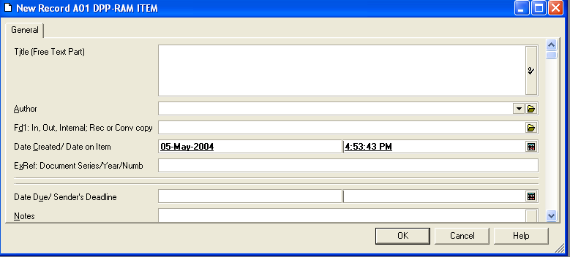

■ To modify or edit title, dates, exeternal reference via Properties
After the initial registration form above is saved, highlight the new record and go to File/Properties or right mouse click/Properties. The ‘General’ tab appears, along with tabbed pages with more data fields for easy viewing and editing via right mouse click on selected item/column.

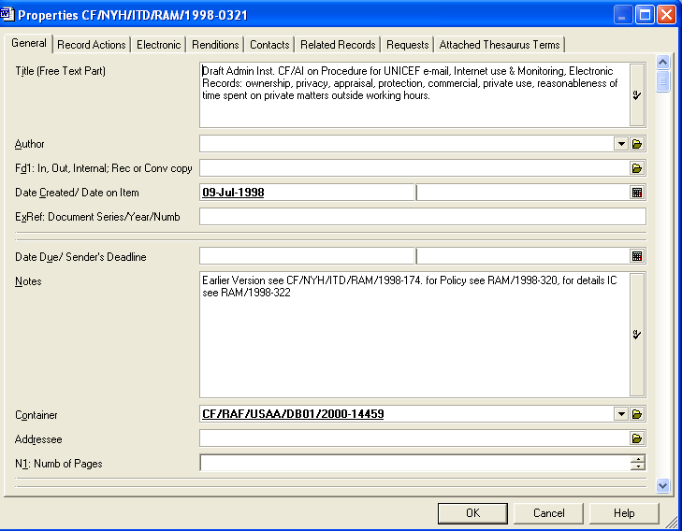

TRIM Context Double Clicking

■ Double-clicking on an item (or list pane) will open up the ‘Properties’ dialog box to allow for adjustments and customization. As more data is added, more tab entries appear. When an electronic file is attached, double clicking will open the electronic file.
.

Context Sensitive Right Mouse Click
■ Right mouse click has replaced many functions of TRIM Captura’s ‘Process, Navigation, Task and Browse’ drop-down menus. In addition to ‘Properties’, right click to add Locations/Contacts, or to check-in or -out an item via Electronic.

Right-click is context sensitive. Within dialogue boxes, right click on an item/pane/column to add or edit.

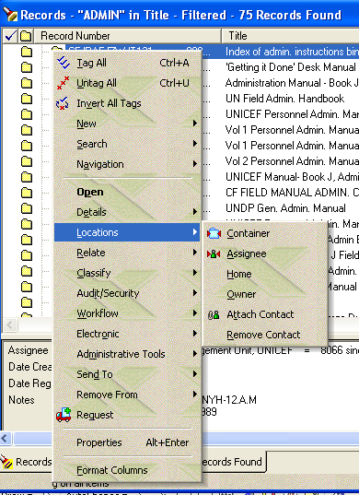

TRIM Context Searching

■ Searching, Sorting and Filtering have been separated into individual tabbed entry pages. Captura’s ‘Select from – Select to’ has been changed to ‘Equal to’ in Context, accessed via the pull-down menu ‘Search’. There is also prefix and suffix wild card searching.
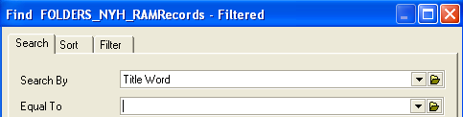

■ Simple Search engine is now built into the toolbar, with previous searches offered in a drop-down menu. (right hand side of screen only shows below)

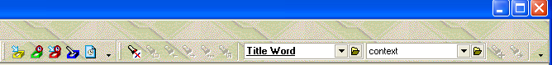

■ Search via right mouse click

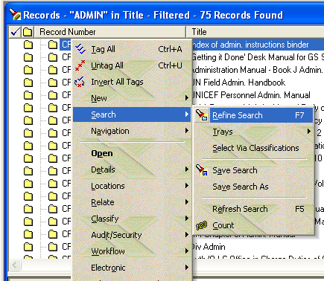

TRIM Context User-Friendly Enhancements:
Sorting, Formatting, Printing and Help

■ Sorting a list pane is much easier by clicking on the column titles to toggle between ascending and descending listing of items according to the specific column category.
■ Formatting columns is easier to add, remove and organize column headings Right click/format columns or right click/hold/grab and move.

■ Scaleable dialogue boxes. Grab bottom right triangle to customize view..
■ Printing reports allows for simplified alphabetical sorting of report templates.
■ Context Sensitive TRIM Help index. A help button appears in each dialog box (next to OK and CANCEL), and when pressed it brings up the relevant help information for that particular function.

Modify Commands and Functions in Context
Standard TRIM  Context Functions | Pull Down Menu or Right Click | Action
New Record | File or right click | Control N
Save | File or right click | Control S
Save Record and Clear | File or right click | Control A
Properties | File or right click | Alt + Enter
Print Report | File  Right Click/send to  R
Copy | Edit or right click | Control C
Paste | Edit or right click | Control V
Cut | Edit or right click | Control X
Clear | Edit or right click | Control + delete
Tag All | Edit or right click | Control + A
Un Tag All | Edit or right click | Control + U
Search | Search or right click | Control F
Refine Search | Search or right click | F7
Refresh Search | Search or right click | F57

